Student Government Association
The University of North Carolina at Greensboro
95th Session of The Student Senate
Tuesday, March 13, 2018, 7:00 p.m.
EUC Dail Room - Screaming School Spirit
Presiding: Mikaela Portugal

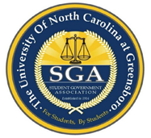

AGENDA
- Call to Order of the 95th Session
- Roll Call
- Approval of Minutes
- Approval of Agenda
- Special Reports
- Reports
  - President Holly Shields
  - Vice President Mikaela Portugal
  - Attorney General Brianna Boggan
- Recess for Committee Meetings
- Committee Reports
- Adjournment

